Erika Schoen
PLNT 4790: Karibu Kenya
Term Paper (1-credit)
January 21, 2011

The purpose of this paper is to fulfill the writing requirement for one credit of Plant Sciences course PLNT 4790: Karibu Kenya. The Karibu Kenya course was designed to expose students to agricultural practices and cultural implications of such practices through a ten-day trip to Kenya, Africa. We visited a variety of sites, from small-scale community gardens to large-scale tea plantations. A highlight and central purpose of this international travel experience was a three-day visit to Manor House Agricultural Centre (MHAC) in Kitale, as well as several daughter organizations founded by MHAC graduates. An unexpected and exciting outcome of the course was the birth of an international exchange program between MHAC and the University of Wyoming.
On a personal note, what I learned on this trip about BioIntensive Agriculture (BIA) supplemented what I already knew about organic farming practices. However, as a student of environmental engineering, my education in organic agriculture and local foods has not been in the classroom but rather from volunteering at the cooperative grocery store during my undergraduate studies in South Dakota, and more recently with ACRES Student Farm at the University of Wyoming. Prior to the Kenya trip, I was familiar with practices related to organic farming such as composting and integrated pest management. I gained additional appreciation for BioIntensive Agriculture as a way to grow many different crops in a small area to provide a local food supply. I found it interesting to learn the importance of double-digging beds, combined with the application of compost.
Due to my primary area of study, I was especially interested in issues related to water resources. We learned about water resource issues when visiting the Lake Navaisha area. We first visited the Flamingo Cut-Flower-for-Export farm. The company employs several practices to reduce its environmental impact, including an irrigation recycle system for increased water efficiency, and artificial wetlands to reduce the amount of nutrients discharged to Lake Navaisha. These wetlands likely take up pesticides as well, although that was not specifically discussed. We were fortunate to have a guest one day named Liz, who works for a non-governmental organization striving to preserve and protect Lake Navaisha. Some of the issues being addressed are water rights, water quality, and lake levels. Only the Kenyan government has authority to regulate use of the lake water, but Liz explained that a grassroots movement was necessary to initiate protection due to government corruption. Fortunately, the government is supportive of the civic action.
At the various site visits, an underlying and often unspoken theme was the socioeconomic impacts of the agricultural practices. For example, at the Finlay tea plantation we drove for miles and miles beyond the main gated entrance, past clusters of homes where plantation workers reside. The physical distance separates plantation workers from the rest of society, since they work, live and play there. We learned that the tea companies are mandated to provide children with an elementary education, but it is possible that higher education is not achieved. Apparently, many children of the plantations grow up to also work on the plantation. There seems to be little opportunity to develop skills for a life beyond the tea estates. We saw virtually no recreational facilities or structures for community activities. In addition, it is worth noting the environmental impacts of the plantations. Much forested area was initially cleared to create the tea production fields, but now companies such as Finlay tout their practices of cyclical eucalyptus replanting after harvest as a form of environmental stewardship. However, Finlay also applies granular fertilizer by air which is likely inefficient and may be contributing to nutrient runoff from the estates. The attitude towards ‘organic’ tea production was reflected by a statement made at the tea-processing facility. When asked, our tour guide emphasized that organic tea production meets the bare minimum requirements. Inside the factory, workers maneuvered over the tea dryers in a large room with no lights. A residential development is located immediately behind the factory, always within hearing distance of the eucalyptus mill that prepared fuel to generate electricity at the factory.
In contrast to the monoculture (in both plant and social regard) of large-scale systems such as the tea plantations, we learned about different aspects of BioIntensive Agriculture by visiting Manor House Agricultural Centre and as well as several community programs initiated by MHAC graduates. MHAC was founded in 1984 to promote sustainable agriculture practices and appropriate technology for family farmers of Africa. Manor House offers educational programs and tours in BioIntensive Agriculture, including a two-year diploma and three-month certificate. The program of study includes instruction and hands-on practice ranging from animal draft power to beekeeping to agricultural economics.
Of great importance, Manor House students are required to participate in community outreach programs, which may be a reason for the success of the many daughter programs that we visited. These programs included the Sustainable Agriculture Community Development Program (SACDEP), Community Sustainable Development Empowerment Program (COSDEP), the Grow BioIntensive Agriculture Centre of Kenya (G-BIACK), The Macedonia Self Help Group and the Kilili Self Help Group. The support network and educational aspects of each group were impressive. I especially appreciated when our male tour guide at Kilili Self Help Group stated that “When you work with women, you succeed.” Such a statement demonstrates that women are valued in this type of community. In addition to sustainable farming practices, these groups also work to address community nutrition, health and empowerment. For example, I learned that amaranth is used as a medicinal plant to boost immunity of HIV patients. At G-BIACK, women’s groups of HIV patients are provided with a goat, and orphans are given rabbits as a means to initiate income and food supply.
The success of the Karibu Kenya course has great potential to grow into a larger educational opportunity for UW and Manor House students. Three Kenyan individuals at Manor House expressed a strong interest in studying at the University of Wyoming. With the help of the UW International Programs Office, an exchange program would be a wonderful opportunity for students from both schools to broaden horizons through international study. Information on effective small-scale agricultural practices could be shared to benefit both countries. An exchange program would also benefit students through the development of critical thinking skills. By studying environmental and socioeconomic impacts in another culture, students may gain a greater ability to recognize and understand impacts in their home country.
Another very important outcome of an international student exchange program would be to improve the practice of sound science at the BIA research sites. While visiting the various BioIntensive Agriculture programs, it became apparent that there is a need for more education on scientific research methods. Experiments at G-BIACK and the Macedonia Self Help group lacked proper experimental design necessary for statistical analyses. As a result, it is not possible to make specific comparisons between BioIntensive and other agricultural practices. For example, it would be useful to compare the yield of beans between plants grown with synthetic fertilizers and those grown with compost. Therefore, theory and research methods could be improved through MHAC students attending the University of Wyoming.
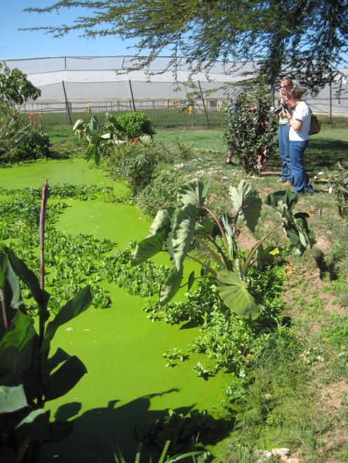
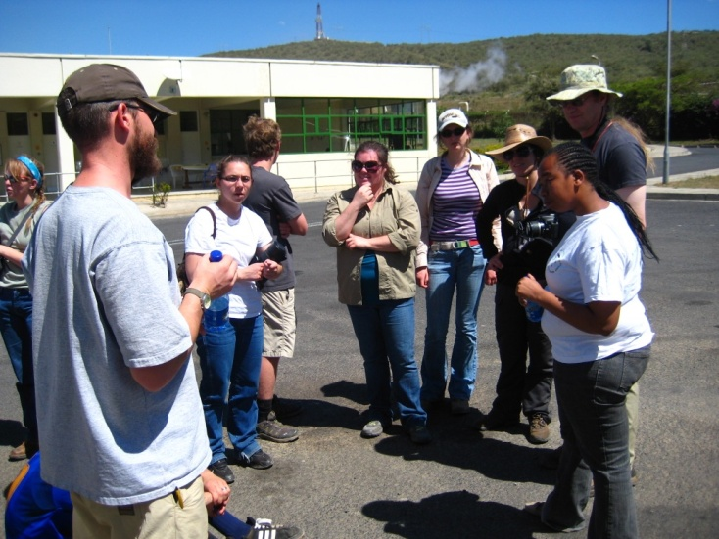

Figure 2: Liz explains issues related to protecting Lake Navaisha to the University of Wyoming group

Figure 1: Artificial wetlands at Flamingo Flower Farm
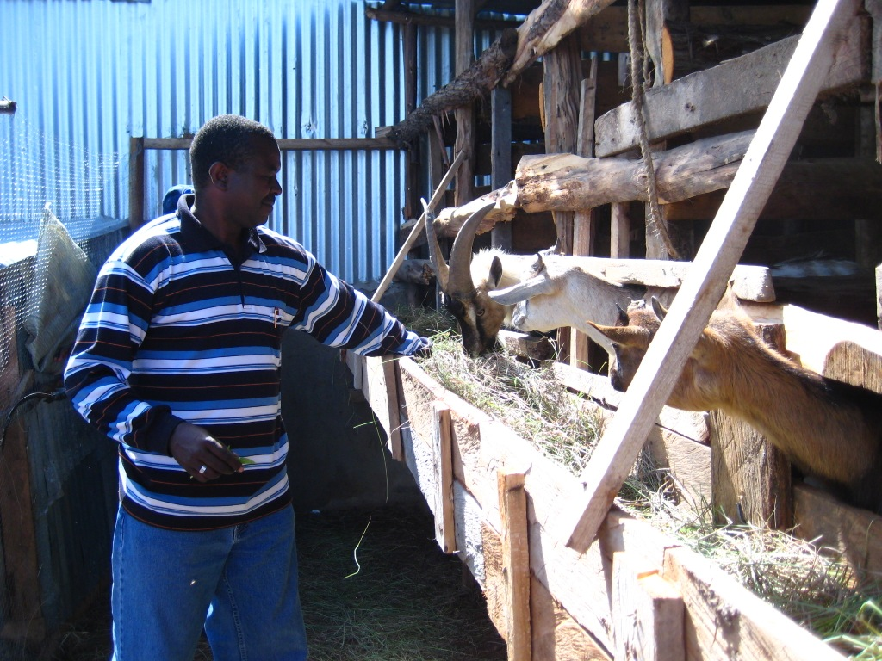

Figure 3: These goats are provided to support groups for HIV- positive women through an outreach program at G-BIACK

